**PHASE 1 PROJECT**

**Project 1: Login page**

<html>

<head>

<style>

input[type=button] {

background-color:c1121f;

border: none;

color: white;

padding: 8px 16px;

}

p,h1{

color:white;

}

</style>

</head>

<body background="b.jpg">

<center>

<h1> LOGIN PAGE</h1>

<form>

<table>

<tr>

<td>

<p>USERNAME:</p>

<td><input type="text" name="name" placeholder="enter your name">

</td></tr>

<tr>

<td>

<p>PASSWORD:</p>

<td><input type="password" name="pass" placeholder="enter your password">

</td>

</tr>

</table>

<br>

<input type="button" value="LOG IN"></td>

<br>

</center>

</body>

</html>

**OUTPUT:**



**Project 1: Sign-up page**

<html>

<head>

<style>

input[type=button] {

background-color:c1121f;

border: none;

color: white;

padding: 8px 16px;

}

p,h1{

color:white;

}

</style>

</head>

<body background="b.jpg">

<center>

<h1> SIGN-UP PAGE</h1>

<form>

<table>

<tr>

<td>

<p>USERNAME:</p>

<td><input type="text" name="name" placeholder="enter your name">

</td>

</tr>

<tr>

<td>

<p>PASSWORD:</p>

<td><input type="password" name="pass" placeholder="enter your password">

</td>

</tr>

<td><p>CONFIRM PASSWORD:</p>

<td><input type="password" name="pass" placeholder="enter again">

</td>

</tr>

</table>

<br>

<input type="button" value="SIGN UP"></td>

<br>

</center>

</body>

</html>

**OUTPUT:**



**PROJECT 2: RESTAURANT LOGIN PAGE**

<html>

<head>

<style>

input[type=button] {

background-color:606c38;

border: none;

color: white;

padding: 8px 16px;

}

p{

color:white;

}

h1{

color:90a955;

}

</style>

</head>

<body background="b.jpg">

<center>

<h1> LOGIN PAGE</h1>

<form>

<table>

<tr>

<td>

<p>USERNAME:</p>

<td><input type="text" name="name" placeholder="enter your name">

</td></tr>

<tr>

<td>

<p>PASSWORD:</p>

<td><input type="password" name="pass" placeholder="enter your password">

</td>

</tr>

</table>

<br>

<input type="button" value="LOG IN"></td>

<br>

</center>

</body>

</html>

**OUTPUT:**

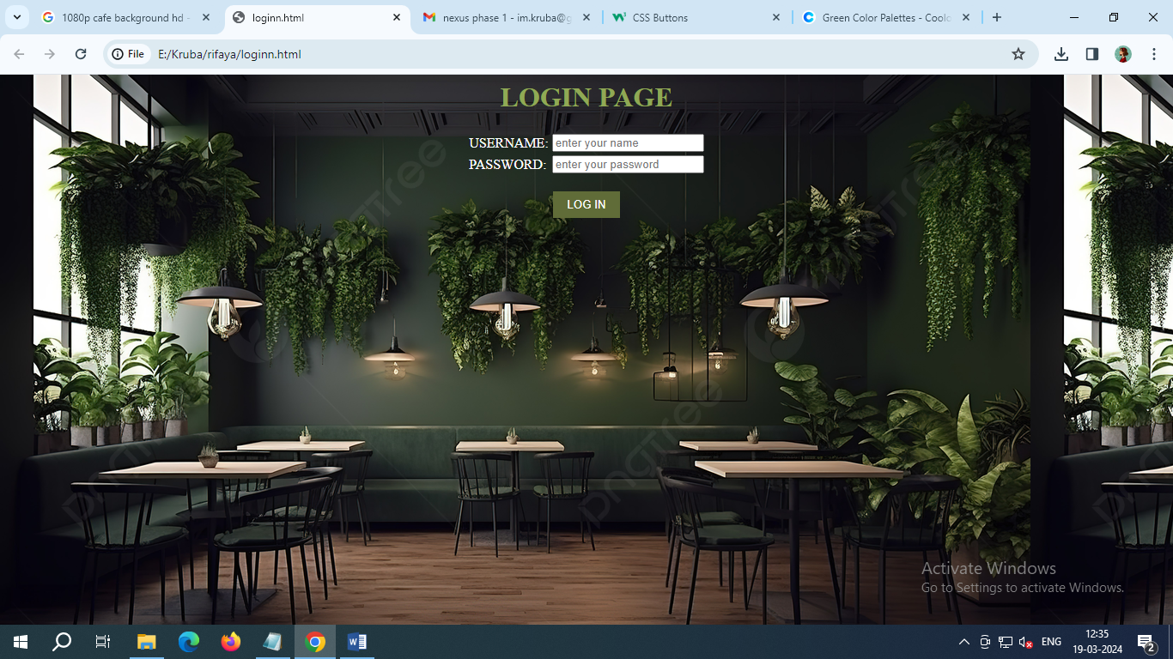

**RESTAURANT SIGN-UP PAGE**

<html>

<head>

<style>

input[type=button] {

background-color:606c38;

border: none;

color: white;

padding: 8px 16px;

}

p{

color:white;

}

h1{

color:90a955;

}

</style>

</head>

<body background="b.jpg">

<center>

<h1> SIGN UP</h1>

<form>

<table>

<tr>

<td>

<p>USERNAME:</p>

<td><input type="text" name="name" placeholder="enter your name">

</td></tr>

<tr>

<td>

<p>PASSWORD:</p>

<td><input type="password" name="pass" placeholder="enter your password">

</td>

</tr>

<tr>

<td><p>CONFIRM PASSWORD:</p>

<td><input type="password" name="pass" placeholder="enter again">

</td>

</tr>

</table>

<br>

<input type="button" value="SIGN UP"></td>

<br>

</center>

</body>

</html>

**OUTPUT:** 